Exercise 11
- SELECT COUNT(*) AS employees_4_or_more_years FROM employee_data WHERE yos >= 4;
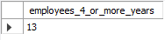
- SELECT age, COUNT(*) AS employee_count FROM employee_data GROUP BY age;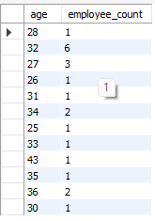
- SELECT age, COUNT(*) AS employee_count FROM employee_data GROUP BY age ORDER BY age DESC;
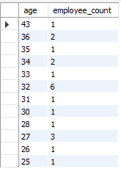
- SELECT title, AVG(age) AS average_age FROM employee_data GROUP BY title;
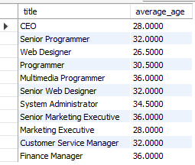
- SELECT title, AVG(age) AS average_age FROM employee_data GROUP BY title ORDER BY average_age DESC;
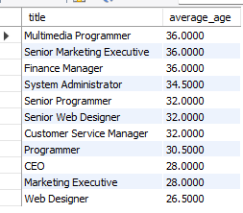
- SELECT f_name, l_name, (perks/salary * 100) AS perk_percentage FROM employee_data ORDER BY perk_percentage DESC;
